**Partitioning between cytochrome *c* oxidase and alternative oxidase studied by oxygen kinetics of dark respiration in *Chlamydomonas reinhardtii*: a microalgae model organism**

Marco Di Marcello1, Iglesias-Gonzalez J1, Meszaros A1,2, Haider M3, Gnaiger E1,2, Huete-Ortega M1

*1Oroboros Instruments, Innsbruck, Austria; 2D Swarovski Research Lab, Dept Visceral, Transplant Thoracic Surgery, Med Univ Innsbruck, Austria; 3SHTech, Innsbruck, Austria*

🖂 [marco.dimarcello@oroboros.at](mailto:marco.dimarcello@oroboros.at)

<http://www.mitofit.org/index.php/Di_Marcello_2019_MitoFit_Preprint_Arch>

****© 2019 Di Marcello *et al*. This is an Open Access extended abstract (not peer-reviewed) distributed under the terms of the Creative Commons Attribution License, which permits unrestricted use, distribution, and reproduction in any medium, provided the original authors and source are credited. © remains with the authors, who have granted MitoFit an Open Access preprint license in perpetuity.

**Editor MitoFit Preprint Archives:** Gnaiger E

**Introduction**

Bioenergetics is the study of how living organisms acquire and transform energy to perform biological work. Energetic coupling between chloroplasts and mitochondria has been described in algae, demonstrating that a good functionality and interaction between both organelles is necessary to maintain metabolic integrity. High-resolution respirometry (HRR) is widely used to assess mitochondrial respiration and other bioenergetics parameters in the biomedical field of mitochondrial research and its clinical applications [1]. In our interdisciplinary study, we adapted the multimodal approach of the Oroboros O2k high-resolution respirometer to investigate algal bioenergetics for biotechnological purposes [2].

In contrast to mammalian cells, algal mitochondria possess alternative oxidases (AOX), which bypass electron transfer from the Q-junction through Complexes CIII and CIV [3]. Therefore, in algae we can distinguish between respiration through the Q-AOX and Q-CIV branches.

**Material and methods**

The microalgal model organism *Chlamydomonas* *reinhardtii* wild-type strain *wt12* was grown at RT in Tris-Acetate-Phosphate (TAP) medium in a 16:8 h light:dark cycle. Oxygen flux, *J*O2, was monitored in *wt12* living cells in the exponential growth phase at 25 °C in Oroboros O2k high-resolution respirometers excluding any light in the chambers. Substrate-uncoupler-inhibitor titration (SUIT) protocols were specifically developed to characterise activities of the Q-AOX and Q-CIV branch (SUIT-022 [4] and SUIT-023 O2 [5], respectively). To quantify the contribution of the Q-AOX branch to algal dark respiration, we studied the oxygen kinetics of (*1*) ROUTINE-respiration in TAP medium, (*2*) Q-AOX dependent respiration after inhibition of CIV with 1 mM potassium cyanide (KCN), and (*3*) Q-CIV dependent respiration after inhibition of AOX with 1 mM salicylhydroxamic acid (SHAM). Oxygen kinetics was obtained from aerobic-anaerobic transitions with high time resolution at a data sampling interval of 0.2 s. *p*50 is the O2 partial pressure, *p*O2, at 50% of maximal respiration, *J*max [6]. The *p*50was calculated from hyperbolic fits using the Oroboros O2Kinetics software for automatic O2 calibration, correction for zero O2 signal drift, instrumental background O2 flux and exponential time constant of the polarographic oxygen sensor [7]. A single shifted hyperbolic fit was used to fit *J*O2 as a function of *p*O2 in each aerobic-anaerobic transition.

**Results and conclusions**

*p*50 ranged from 0.06 to 0.08 kPa for ROUTINE-respiration with an excellent fit by a first-order hyperbolic function. This oxygen affinity is comparable to that in small mammalian cells [8]. Upon inhibition of CIV with KCN, *J*O2 was significantly impaired (Fig. 1A) and *p*50 increased three-fold up to 0.35 kPa (Fig. 2). No decline of *J*O2 and *p*50 was observed relative to ROUTINE-respiration after inhibition of AOX with SHAM (Fig. 1B). In all cases, excellent fits of respiration as a function of oxygen pressure were obtained by a first-order hyperbolic function.

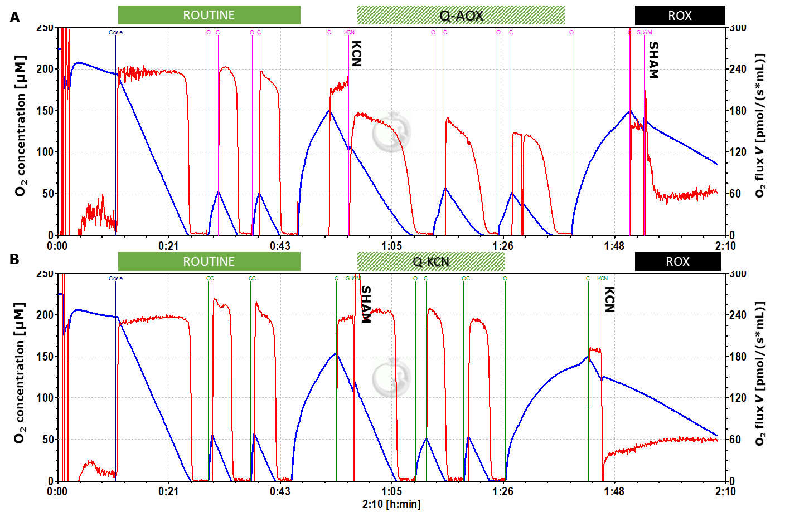

**Figure 1. High-resolution respirometry for the study of dark respiration and O2 kinetics with *C. reinhardtii wt12.*** Representative O2k traces showing O2 concentration and O2 flux per chamber volume with repeated aerobic-anoxic transitions (O2 kinetics) and re-oxygenations. **A:** Protocol SUIT-022: AOX-ce CN+SHAM. **B:** Protocol SUIT-023: AOX-ce SHAM+CN. Note the high technical reproducibility of ROUTINE-respiration in both protocols, and the identical and relatively high residual oxygen consumption, *Rox*, after titration of both inhibitors in both protocols.



**Figure 2. *p*50 in living cells of *C. reinhardtii* in the ROUTINE-state of respiration, and metabolic pathways restricted to the Q-AOX or Q-CIV branch.** O2 kinetic experiments were run in presence of the cytochrome *c* oxidase inhibitor potassium cyanide (AOX group) or the alternative oxidase inhibitor salicylhydroxamic acid (CIV group). The data represents *n*=8 technical replicates, *N*=2, median ± IR.

If the potential contribution of the Q-AOX branch in the ROUTINE-state would be compensated for by increased Q-CIV flux after addition of SHAM, then the mixed Q-AOX and Q-CIV fluxes would give rise to biphasic hyperbolic oxygen kinetics, with a contribution of the high-affinity Q-CIV branch and the low-affinity Q-AOX branch. Taken together, our results provide evidence against a contribution of AOX to ROUTINE-dark respiration in *wt12* cells under the presently applied culture conditions. Oxygen kinetics provides a sensitive and fast method for detection of Q-AOX and Q-CIV contributions to dark respiration in living cells. This kinetic approach is based on the difference of O2 affinities of the two pathway branches, which will extend our understanding of the bioenergetics and physiology of all types of cells harbouring AOX and CIV.

Supported by project NextGen-O2k, which has received funding from the European Union’s Horizon 2020 research and innovation programme under grant agreement No 859770

**References**

1. Doerrier C, Garcia-Souza LF, Krumschnabel G, Wohlfarter Y, Mészáros AT, Gnaiger E (2018) High-Resolution FluoRespirometry and OXPHOS protocols for human cells, permeabilized fibers from small biopsies of muscle, and isolated mitochondria. Methods Mol Biol 1782:31-70. - [www.bioblast.at/index.php/Doerrier_2018_Methods_Mol_Biol](http://www.bioblast.at/index.php/Doerrier_2018_Methods_Mol_Biol)
2. Pulz O & Gross W (2004) Valuable products from biotechnology of microalgae. App. Microbiol. Biotech. 65(6): 635-648.
3. Young L, Shiba T, Harada S, Kita K, Albury MS, Moore AL (2013) The alternative oxidases: simple oxidoreductase proteins with complex functions. Biochem Soc Trans 41:1305-11.
4. [www.bioblast.at/index.php/SUIT-022_O2_ce_D051](http://www.bioblast.at/index.php/SUIT-022_O2_ce_D051)
5. [www.bioblast.at/index.php/SUIT-023_O2_ce_D053](http://www.bioblast.at/index.php/SUIT-023_O2_ce_D053)
6. Gnaiger E (2001) Bioenergetics at low oxygen: dependence of respiration and phosphorylation on oxygen and adenosine diphosphate supply. Respir Physiol 128:277-97. - [www.bioblast.at/index.php/Gnaiger_2001_Respir_Physiol](http://www.bioblast.at/index.php/Gnaiger_2001_Respir_Physiol)
7. Meszaros AT, Haider M, Di Marcello M, Gnaiger E (2018) High-resolution mitochondrial oxygen kinetics as diagnostic tool in Complex IV impairments. Abstract Mitochondrial Medicine 2018 Hinxton UK.

- [www.bioblast.at/index.php/Meszaros_2018_Mt_Med_Hinxton](http://www.bioblast.at/index.php/Meszaros_2018_Mt_Med_Hinxton)

8. Scandurra FM, Gnaiger E (2010) Cell respiration under hypoxia: facts and artefacts in mitochondrial oxygen kinetics. Adv Exp Med Biol 662:7-25. - [www.bioblast.at/index.php/Scandurra_2010_Adv_Exp_Med_Biol](http://www.bioblast.at/index.php/Scandurra_2010_Adv_Exp_Med_Biol)